Yu Chang Ou & Kendra Crawford

ECE318 | Spring 2017

Professor Traver

**Milestone 1** | Problem Definition Draft | **Typing Tutor**

Project Goals

The goal of this project is to design a typing game which allows the user to learn how to type quickly on the keyboard by implementing the educational aspect of the objective into a game. We would like to design a system which takes inputs from the keyboard control and output the game’s results on the screen. Intermediate outputs would use the LCD display on the FPGA screen which will keep track of the “score” (one point per a correct letter typed) and use a counter to keep track of the “time” it took the user to initiate and complete the entry of the word. At the end of the game, the user is given their score in juxtaposition to the highest scoring user with the shortest time of completion. If the user happens to be the one with that record, their results are now recorded into the “highest score” category.

The game begins with an opening screen which prompts the user to begin the game. When the game begins, a word is displayed in the center of the screen.

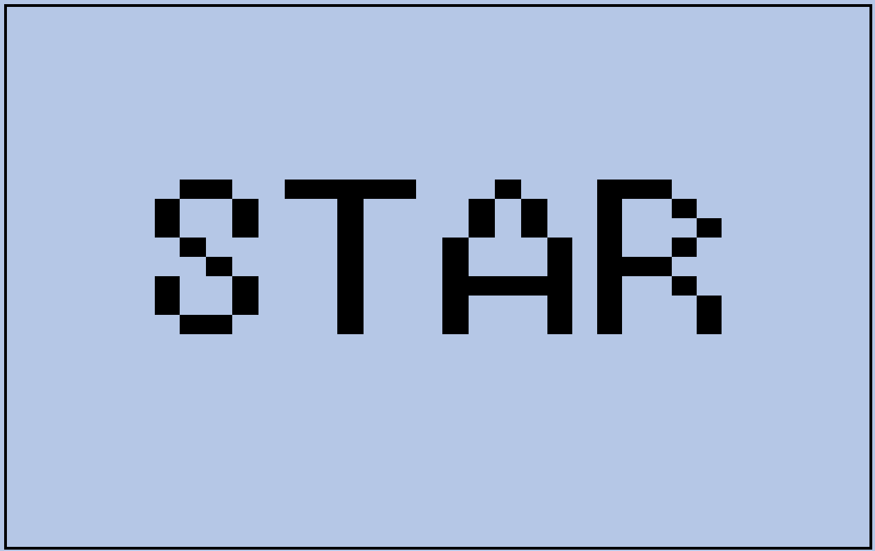

The user must type the word that is being displayed. When they type the letter correctly, the color of the letters will be changed to green. One point is given when the correct letter is typed.

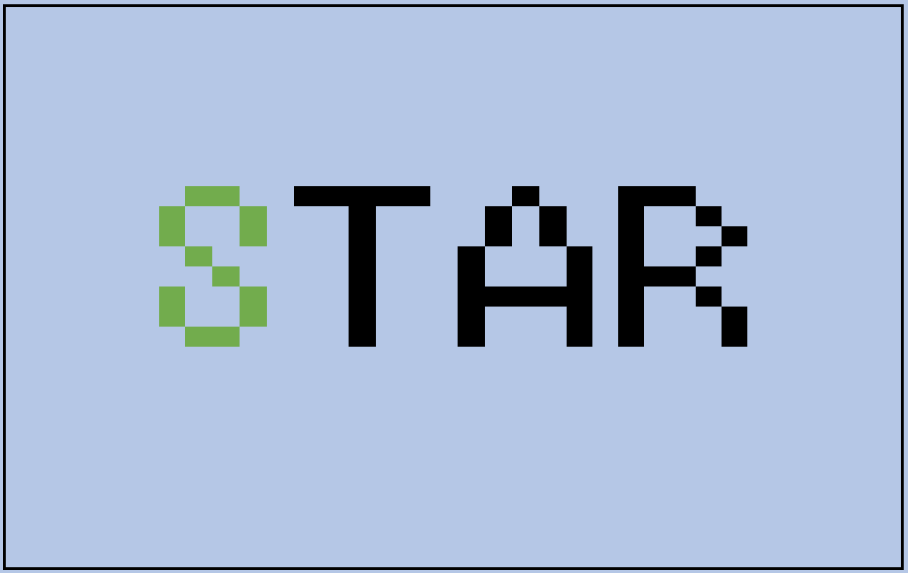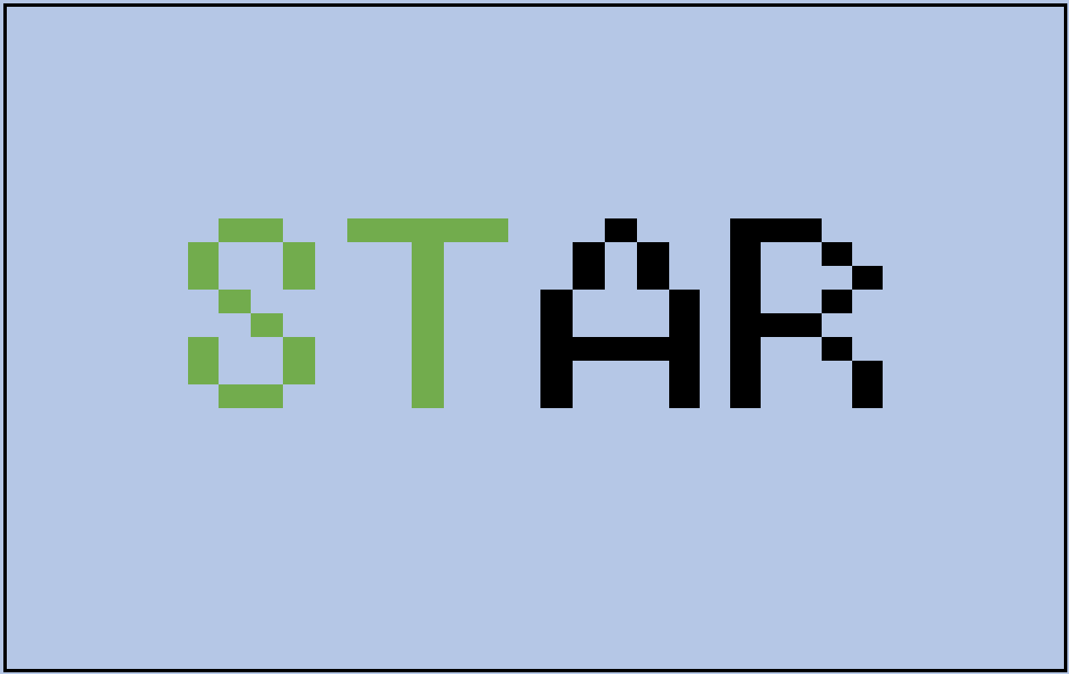

When the letter is typed incorrectly, the color of the letter will be displayed in red until the correct letter is hit, the letter will reappear in green, and the user is only then allowed to continue. However, the user will not get a point for the wrong letter typed even with the correction.

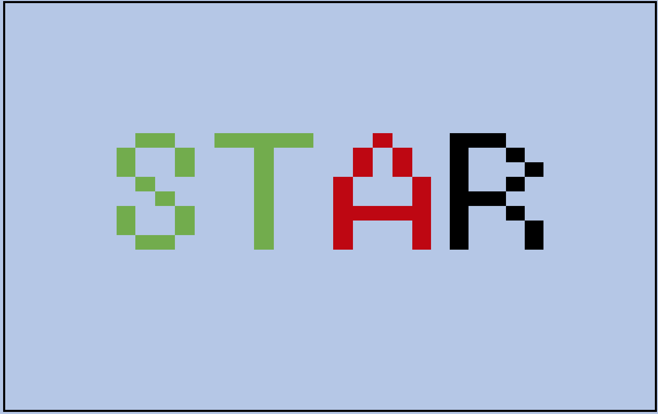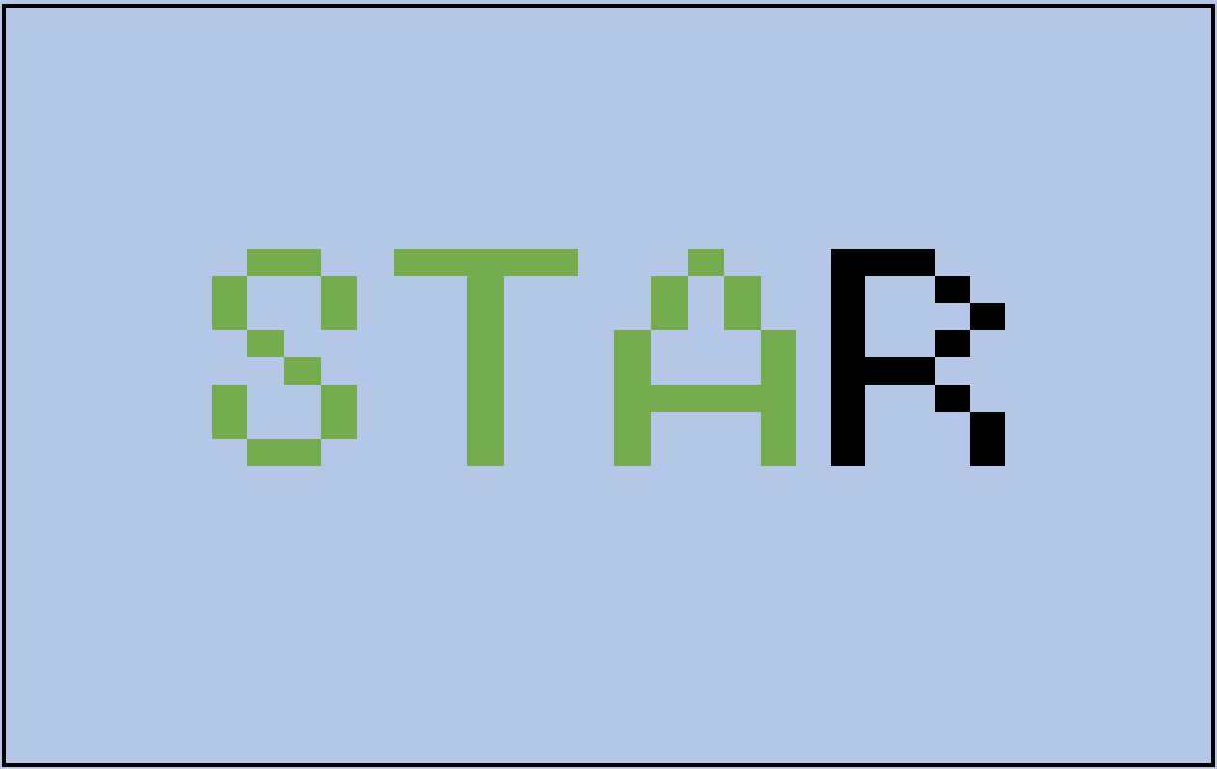

The score and time is kept track of on the LCD display. The score is kept with the mechanism implemented in the counter, and the time is implemented with a cascading lpm counter.

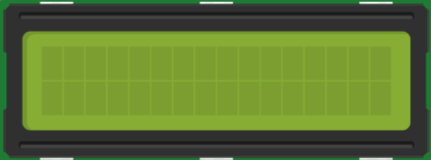

S c o r e : 9

T i m e : 0 0 : 0 3 : 1 4

The end screen will take the time that was recorded and divide it against the score on the LCD to get the “best score” which is calculated by letters typed per second.

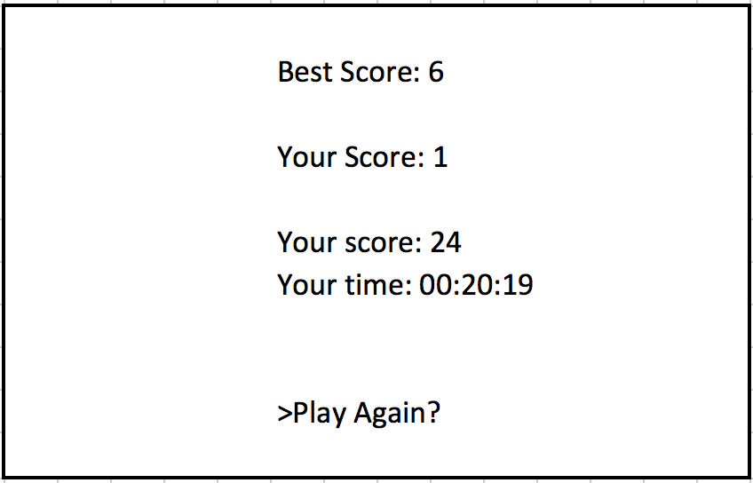

Project I/O

There will be one system reset button which will be the SW0 pushdown button on the DEII board. All other inputs of this system will solely be triggered by the commands on the keyboard.

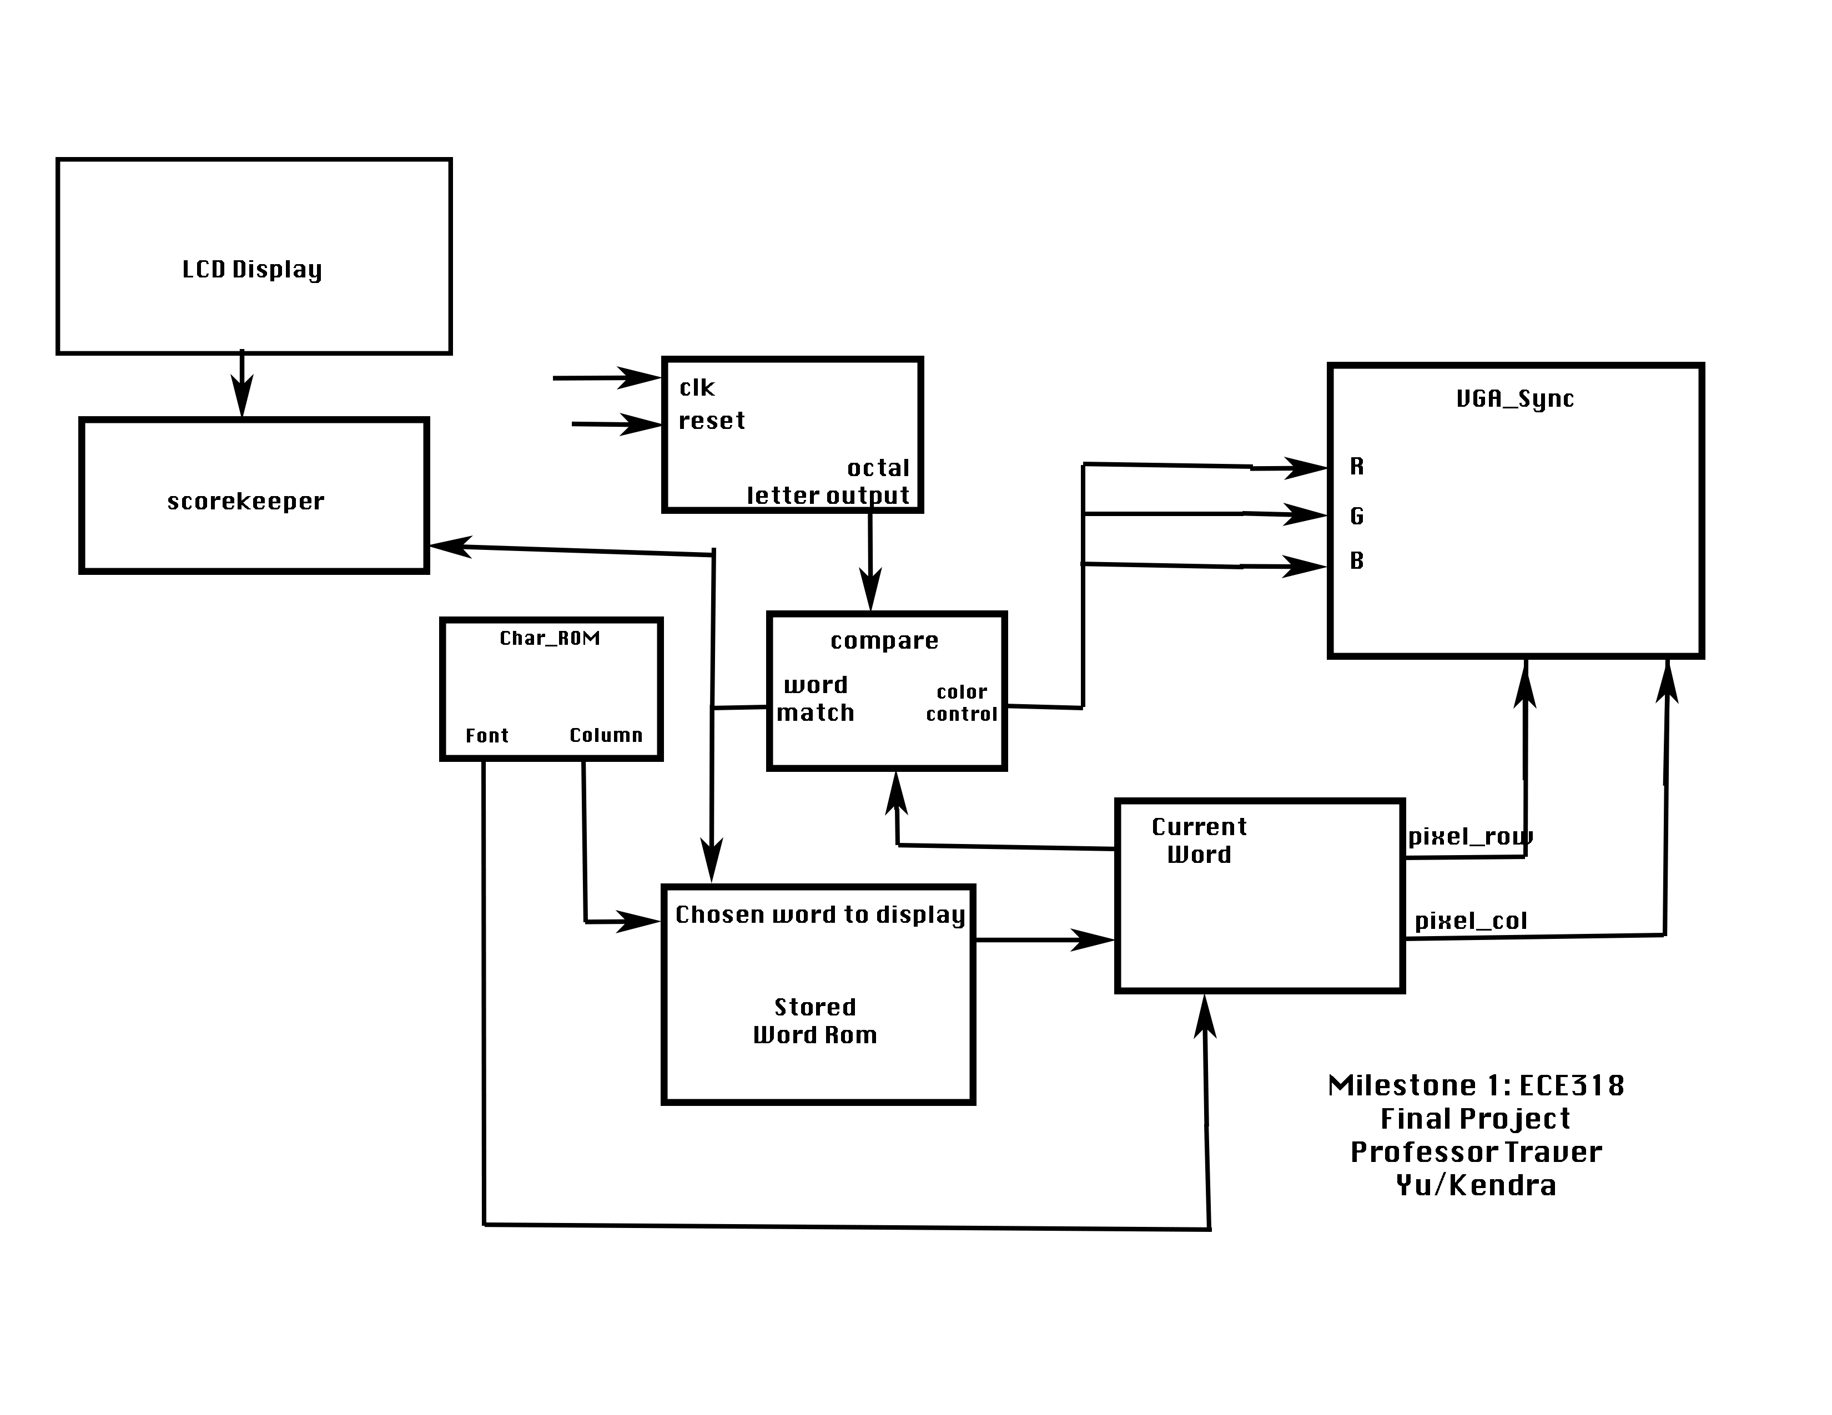

The DEII board will control all the main functions of this system such as displays to the VGA monitor and LCD screen.

Preliminary Test Plan

The most important part is to test the ability of the keyboard to DEII board relationship such that when a key is triggered, the action is recognized, and is then able to perform an action on the VGA display. Similar to the keyboard module created, we must now be able to link the keyboard to the VGA display. The easiest way to do this is to have the letter appear on the screen when the character is pressed, without the game component.

Further internal components:

* Keyboard interface
  + LPM_ROM change to display characters
* VGA screen
  + Connect letter specification from LPM_ROM to display
* Counter
* LCD display